Date :23/1/2026
8. Create a Virtual Hard Disk and allocate the storage using virtual box.
AIM:
To create a virtual hard disk and allocate storage using Oracle VirtualBox.

SOFTWARE USED:
- Oracle VM VirtualBox (Version 7.x)
- Windows 10 / Windows 11

PROCEDURE:
- Open Oracle VM VirtualBox from the Start menu.
- Click on the New button to create a new virtual machine.
- Enter the Virtual Machine name, select:
- Type: Linux
- Version: Ubuntu (64-bit)
- Click Next and allocate 2048 MB (2 GB) RAM for the virtual machine.
- Select Create a Virtual Hard Disk Now and click Next.
- Choose VDI (VirtualBox Disk Image) as the disk type.
- Select Dynamically Allocated so the disk uses space only when required.
- Allocate 15 GB of storage space for the virtual hard disk.
- Click on Finish to complete the process.

Output:

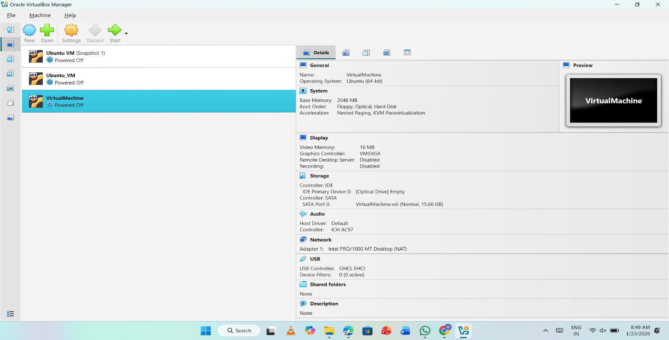

RESULT:
The virtual hard disk was successfully created and storage was allocated using VirtualBox.

